**Bahria University, Lahore Campus**

Department of Computer Sciences

Lab Journal 01

**(Spring 2024)**

|  |  |  |
| --- | --- | --- |
| Course: | **Operating System Lab** | Date: 2-22-2024 |
| Course Code: | CSL-320 | Max Marks: 20 |
| Faculty’s Name: | Abdullah |  |

Name: Muhammad Hammad Enroll No: 03-134221-024

**Objective(s):**

To understand basic concepts of Operating System.

**Tool(s) used:**

Ubuntu, VIM

**Tasks:**

**Task 1 : What is an Operating System?**

An operating system (OS) is the program that, after being initially loaded into the computer by a boot program, manages all of the other application programs in a computer. The application programs make use of the operating system by making requests for services through a defined application program interface (API). In addition, users can interact directly with the operating system through a user interface, such as a command-line interface (CLI) or a graphical UI (GUI).

**Task 2 : Which OS is being used in the Lab?**

Operating System used in the Lab is Windows 10 pro and UBUNBTU.

**Task 3 : Install VMWARE and UBUNBTU on your laptops.**

To install VMware and Ubuntu on your laptops, you'll first need to download VMware software from their official website and then download the Ubuntu ISO file. Once VMware is installed, you can create a new virtual machine and install Ubuntu on it by following the prompts within VMware.

**Task 4 : What is a Virtual Machine? Differentiate between Guest and Host OS**.

A Virtual Machine (VM) is a compute resource that uses software instead of a physical computer to run programs and deploy apps. One or more virtual “guest” machines run on a physical “host” machine. Each virtual machine runs its own operating system and functions separately from the other VMs, even when they are all running on the same host. This means that, for example, a virtual MacOS virtual machine can run on a physical PC.

|  |  |
| --- | --- |
| **Guest** | **Host** |
| The Guest operating system runs within the virtual machine. | The Host operating system is the operating system installed directly on the physical hardware. |
| The Guest OS operates within the virtual environment provided by the VM software. | The Host OS manages the hardware resources and provides services to the guest OS. |

**Lab Grading Sheet :**

|  |  |  |  |
| --- | --- | --- | --- |
| **Task** | **Max Marks** | **Obtained Marks** | **Comments(*if any*)** |
| 1. | 05 |  |  |
| 2. | 05 |  |  |
| 3. | 05 |  |  |
| 4. | 05 |  |  |
| **Total** | **20** |  | **Signature** |

Virtual Box – An Introduction:

Virtual Box is a powerful x86 and AMD64/Intel64 virtualization product for enterprise as well as home use. Not only is Virtual Box an extremely feature rich, high-performance product for enterprise customers, it is also the only professional solution that is freely available as Open-Source Software under the terms of the GNU General Public License (GPL) version 2.

When we describe Virtual Box as a "virtualization" product, we refer to "full virtualization", that is, the particular kind of virtualization that allows an unmodified operating system with all of its installed software to run in a special environment, on top of your existing operating system. This environment, called a "virtual machine", is created by the virtualization software by intercepting access to certain hardware components and certain features. The physical computer is then usually called the "host", while the virtual machine is often called a "guest". Most of the guest code runs unmodified, directly on the host computer, and the guest operating system "thinks" it's running on real machine.

Learn more at [https://www.virtualbox.org](https://www.virtualbox.org/)/

Now we will start Installing Virtual Box in Windows, to install Ubuntu as virtual machine.

# Installing Virtual Box:

You can download Virtual Box version 4.2 from following link. This version is old one but proved to be more stable as compared to latest one.

[https://www.virtualbox.org/wiki/Download_Old_Builds_4_](https://www.virtualbox.org/wiki/Download_Old_Builds_4_2)2

After Download complete of latest version Virtual Box 4.3.26, click on downloaded exe.

**Step1**: Following Welcome screen will appear.

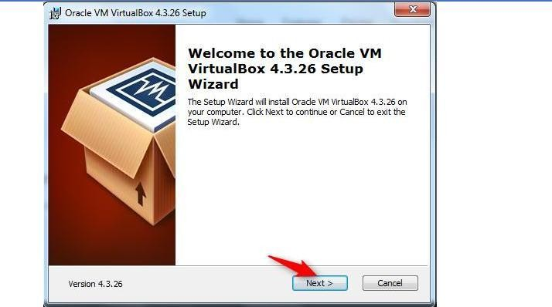

Click “Next” button.

**Step2:**

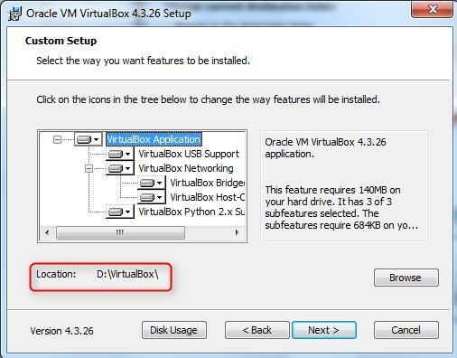

Click Next.

**Step3**: Custom Setup for different features Window is displayed. No need to change anything, just press “Next” button.

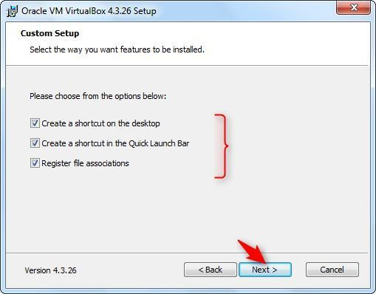

**Step 4:** Warning window is displayed. Click Yes.

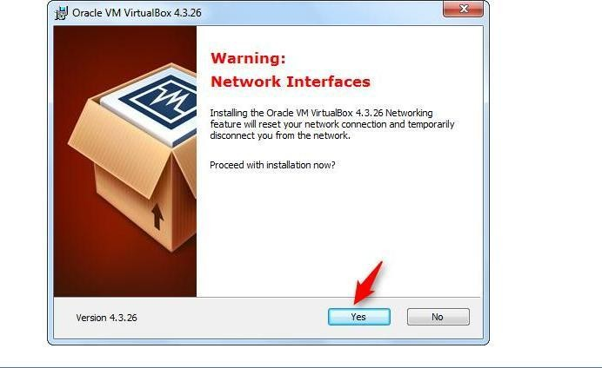

**Step5**: “Ready to Install” window is displayed. Press “Install” button.

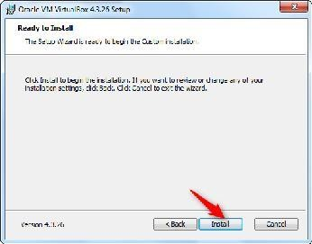

**Step6:** Finally after setup, installation will start and following window will be displayed with status bar.

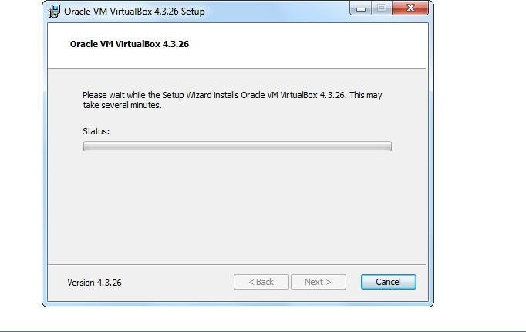

Installation continues…

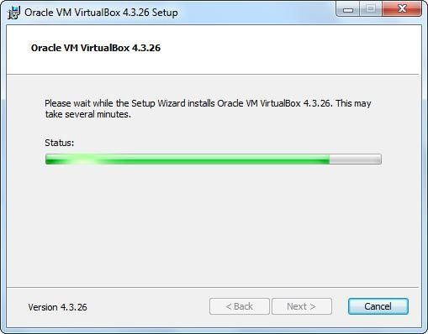

Meanwhile Windows Security will ask for the confirmation of installing hardware. e.g below.

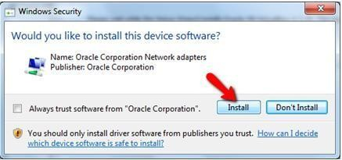

Press Install.

**Step7:** Installation Complete. Press “Finish” button.

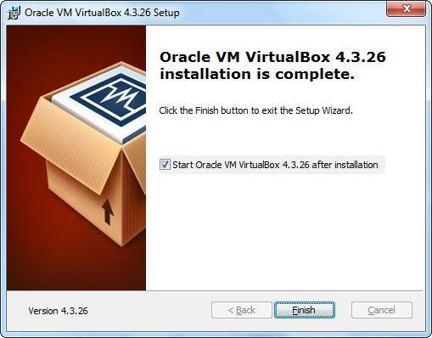

After installation completed, you can find its icon on desktop.

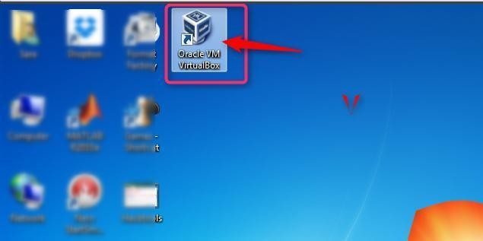

# Setting up Virtual Machine:

**Step1:** Click the Virtual Box icon and following window will be opened.

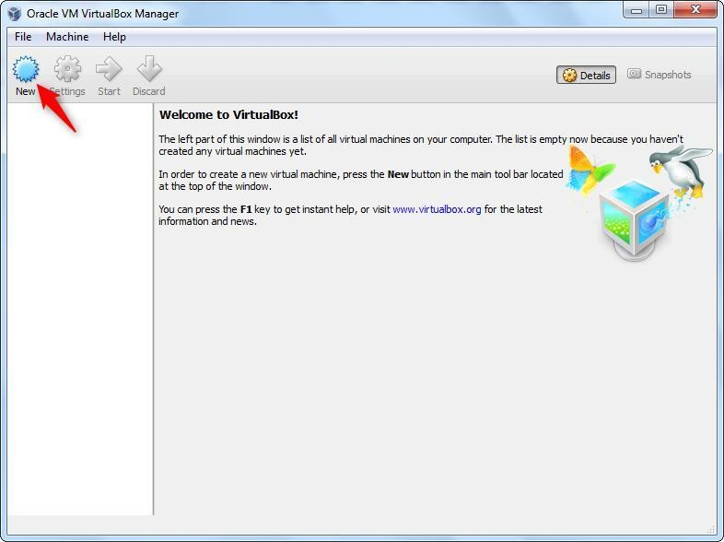

Click on “New” button on top of menu bar.

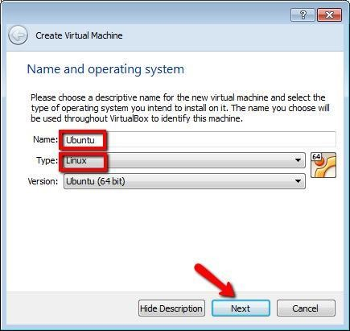**Step2**: Step1 will lead you to setup a new virtual machine.

Following window will be opened to setup virtual machine name and type. Press Next.

**Step3:** By pressing “Next”, following window will be opened to setup memory size.

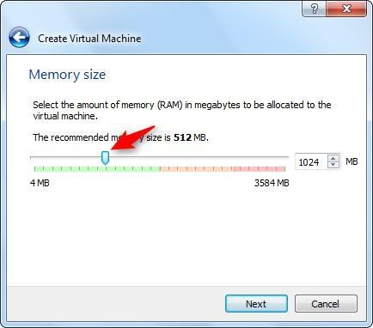

Press Next.

**Step4:** By pressing “Next”, “Hard drive” window will be opened. Select “Create a virtual hard drive now”.

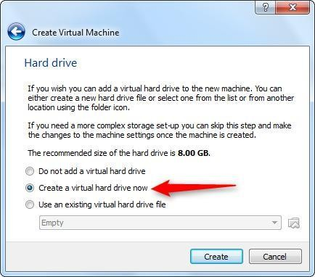

Press “Create” button.

**Step 5:** By default VDI option is selected. Do not make any change and just press “Next”.

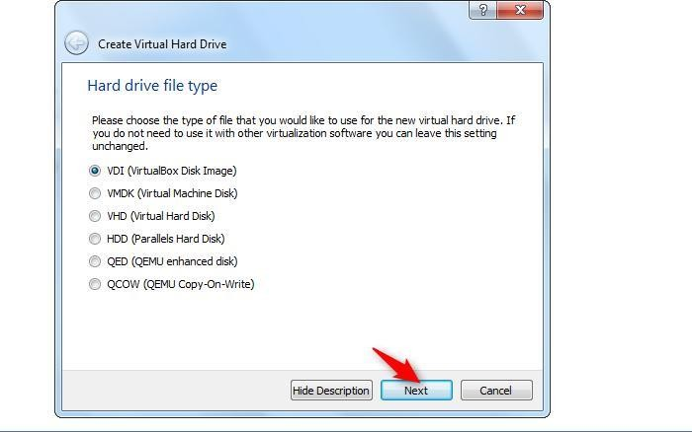

**Step6:** Select “Dynamically allocated”.

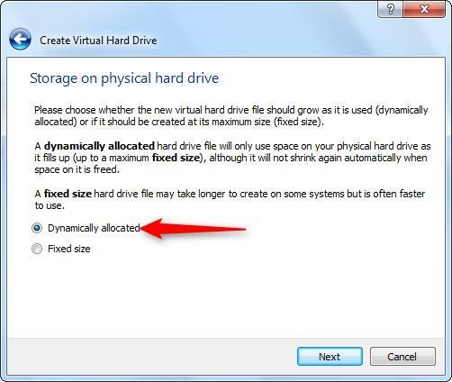

**Step7:** Following window will be opened to setup virtual hard drive size. Here 15 GB is selected but you can select it up to 40GB if free space is available.

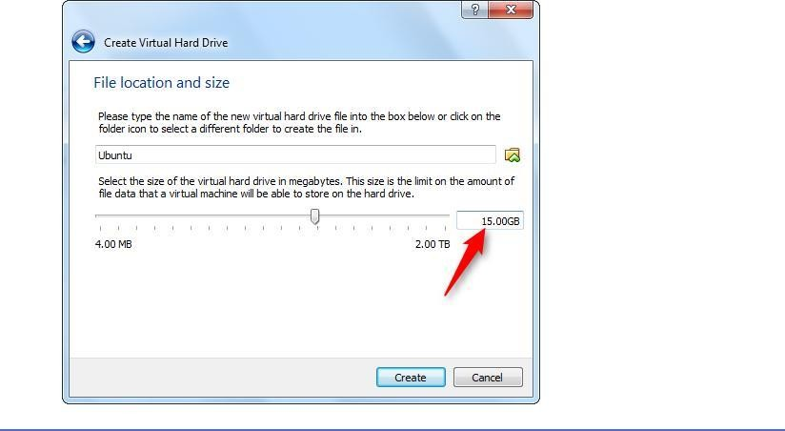

Press “Create” button.

**Step8:** Following window will appear with one virtual machine named “Ubuntu” will be added in left panel.

Click on “Start” button highlighted.

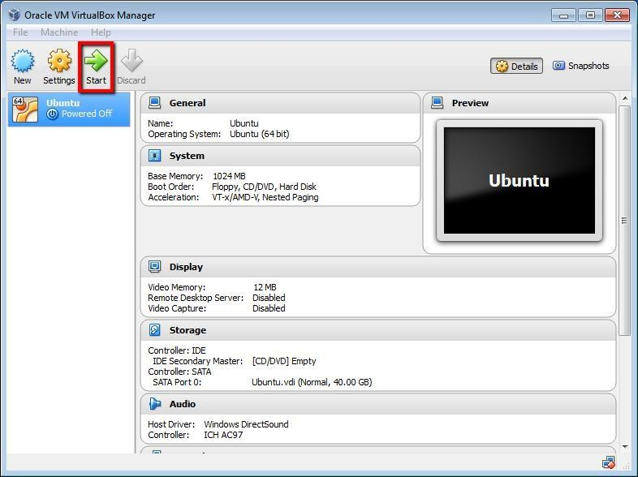

**Step9:** In order to attach ISO image with this virtual machine.

* 1. Click on “Settings” button. Following settings window will open.
  2. Go to Storage Option. Under “Storage Tree” go to Controller: IDE.
  3. Select “Empty” option. By selecting “Empty” Attributes will be changed.
  4. Click on CD icon pointed by arrow in below image.

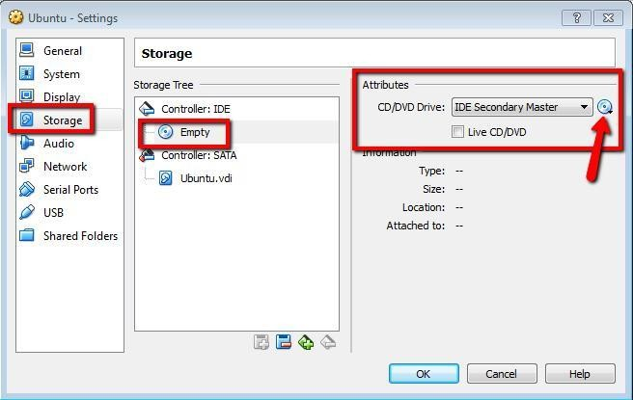

* 1. By clicking at icon of CD, following menu will be displayed.

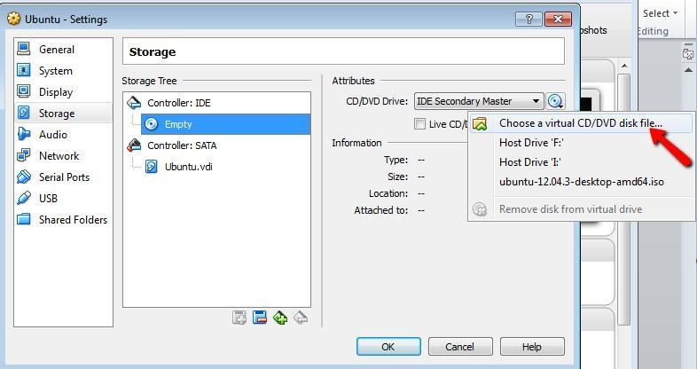

* 1. By clicking on “Choose a virtual CD/DVD disk file… An “Open Window” will appear. Select .iso image and click “Open” button.

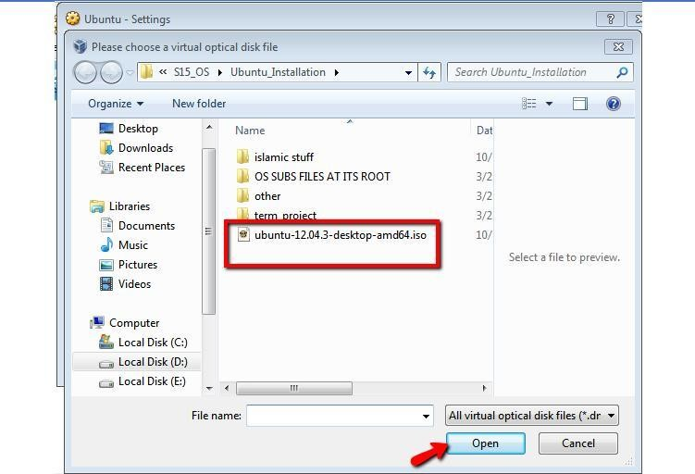

* 1. Now it’s added here. Press “OK” button.

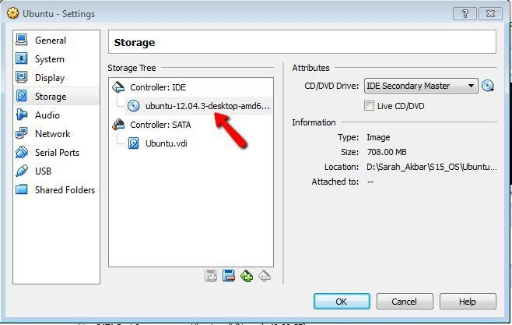

**Step 10:** Click “Start” button and following window will appear.

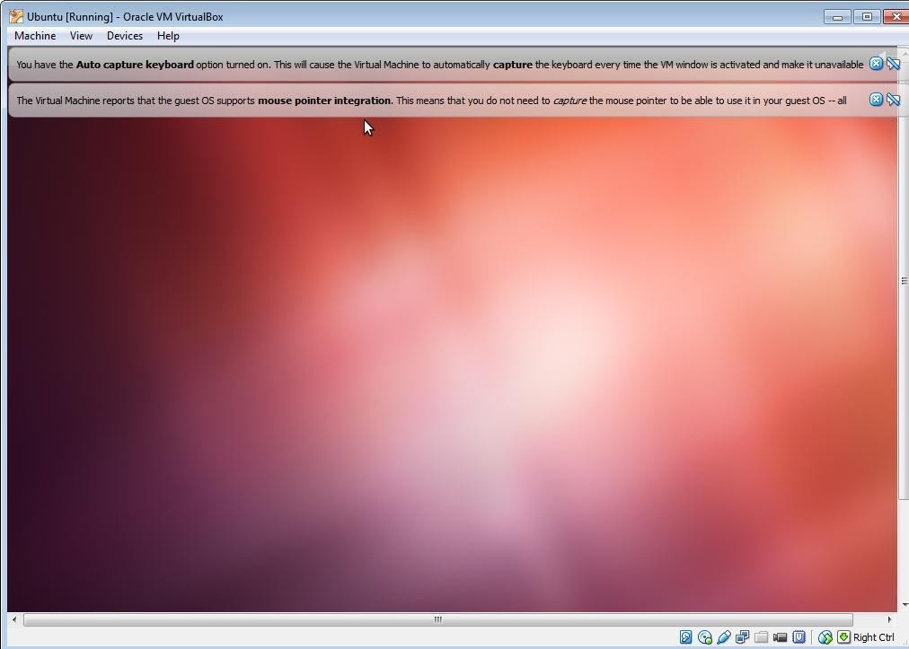

# Installing Ubuntu

**Step1:** Now you will start installing Ubuntu from ISO image just added in virtual machine named “Ubuntu”

When following screen will appear

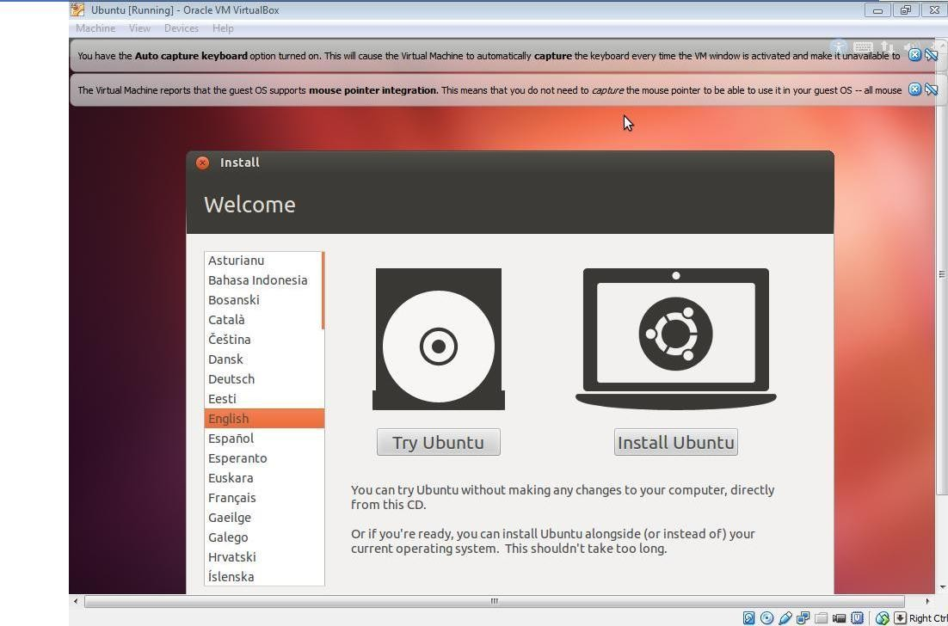

**Step2:** Select “Install Ubuntu” button.

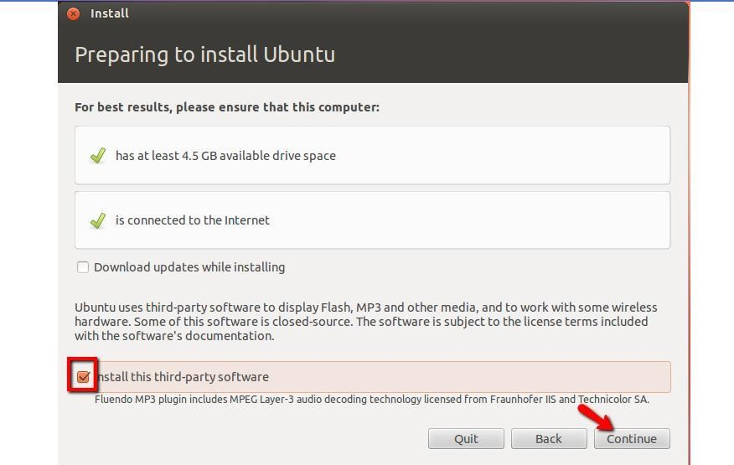

Click Continue.

**Step3:** Select highlighted option below.

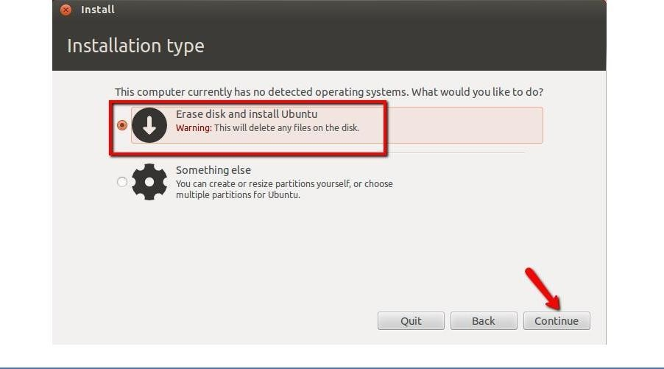

**Step4: Click “Install now”**

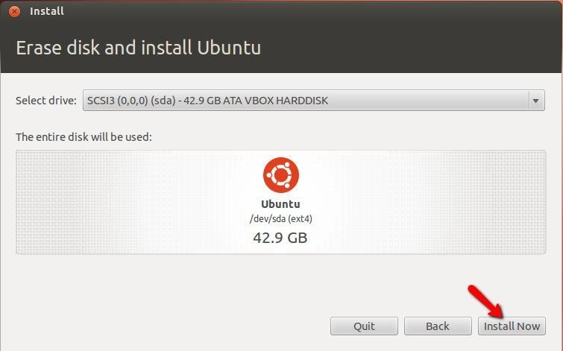

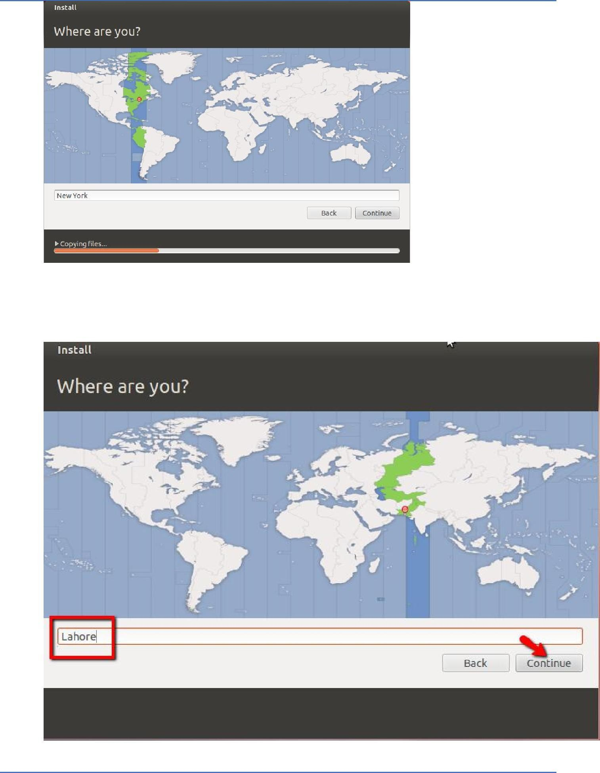

|  |  |
| --- | --- |
|  |  |
| **Step6:** Choose Language |  |

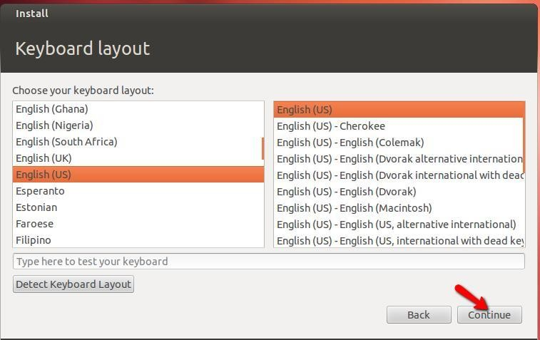

**Step7:** Give username and password information.

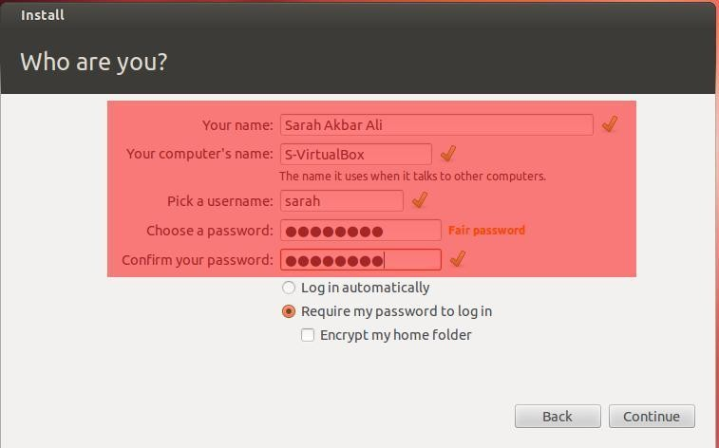

**Step8:** Following welcome window displayed.

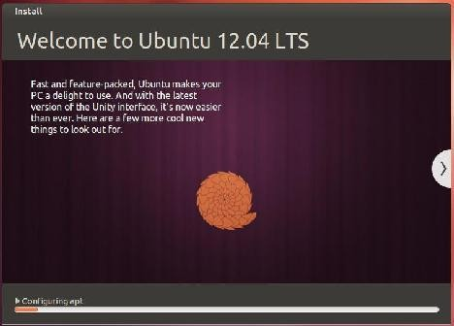

**Step9: Restart system.**

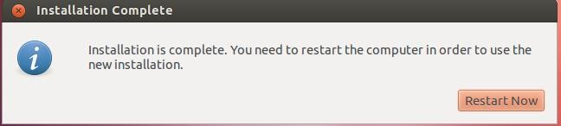

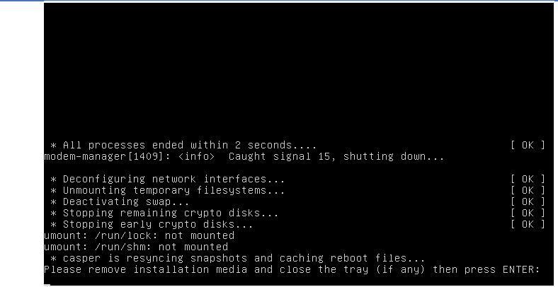

**Step 10:** Press “Enter”. Following screen displayed.Login

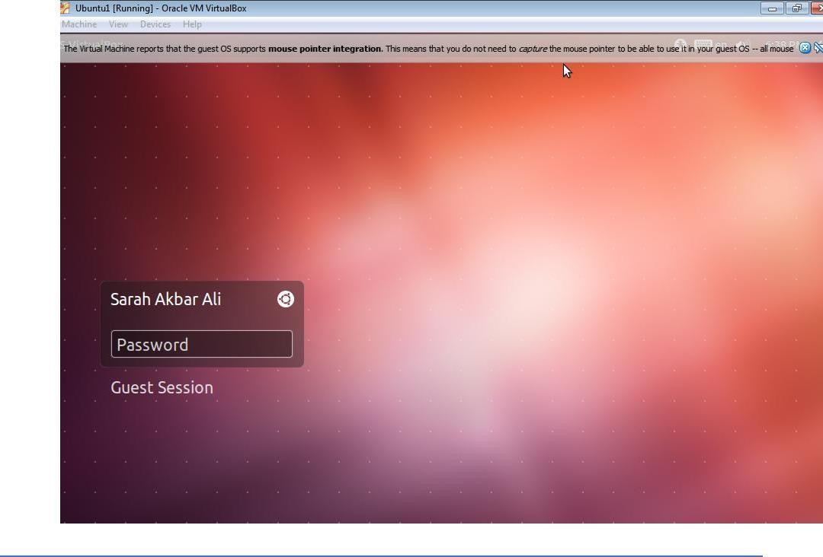

|  |  |
| --- | --- |
|  |  |
| **Step11**: Desktop of Ubuntu displayed. | |

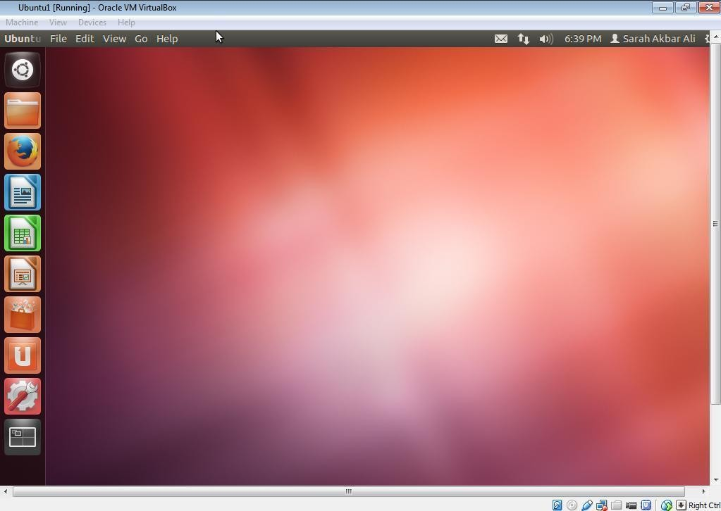

**Step12:** After Installation completed, Go to settings and delete Storage link to iso image.